**Group Assignment Proposal**

**Group members: Quinton, Peter, Lorenzo, Lewis**

1. Application Name - Stockhive

2. Initial architectural front and back end

Our application will be a business portal for retail operations, its key use would be for bulk ordering and tracking of stock purchases. It could also be utilized for managing current sales of stock bought, tracking customer engagement, showing predicted amounts recommended to be purchased and which vendors could provide the best deals for each. For this we would use Java to create the initial front end UI elements in combination with back-end structures such as local databases or firebase to store users’ data.

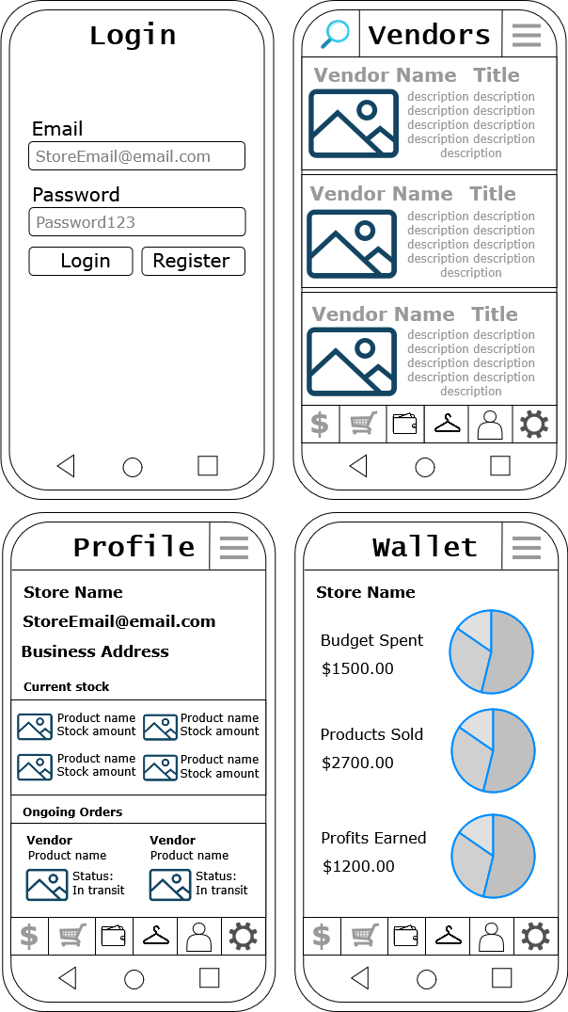3. Screen Design:

4. Description of initial implementation:   
We will be creating a basic UI setup using XML Layouts to display our features. We will also be setting up navigation between different screens using buttons to browse the various vendors and access functions such a user’s profile or customer analytics. The app will also utilize basic functionality like user input, display lists in a recycler view, and firebase for storing data in a database, to achieve this.

5. While developing the application, some of the complications of the application development could be ensuring the best user experience, device compatibility/screen size, and choosing the best development approach. This would more specifically include trying to work with multiple activities at once to allow the user to access multiple different screens and menus within the app, in a convenient manner.

6. We need to learn how to properly format the app in such a way that all the different features can be accessed easily and without issue, we will need to learn how to properly design a way in which this can be achieved. We will also need to learn more about how Java code can be applied on android, utilizing multiple built in functionalities to achieve our desired design. Because our app will also take advantage of databases, local or cloud, we will also need to learn more about how to properly store and retrieve this data so it can be properly applied within our application.

7. Some of the more difficult concepts in Android/Kotlin/Java that we might have to learn are understanding layouts, activities, and ensuring that users can navigate through the app with no issues. We will also need to understand UI Testing, and debug crashes with Logcat.

8. Although the idea of our project may be ambitious, if we keep the design rather simple and maintain a realistic view of our own skills, we should be able to implement each of our specified features in a way that meets the requirements but also does not require skills or knowledge beyond what we will be able to learn within the development timeframe.

9. There are multiple risks we could potentially face during the development of this project, these include a lack of time management, communication or collaboration. Without keeping these factors in mind throughout development, we could run the risk of not achieving enough progress in the given time or creating a sub-par application which does not meet our specifications given. Other risks include the prevalence of bugs, without proper testing we could easily create a product that is filled with many issues which will hinder the user experience and effectiveness of the app.

10. We will be setting up the project in Android Studio, using XML for the UI, and integrating firebase to store data in the database. The initial phase will be to configure Firebase and add it to our project. We will also need to set up the database and ensure data flow works correctly for real time updates and storage.

Mobile Business Portal App

Requirements

Users

*Commercial*

* Bulk purchasing view
* Discounted
* Business-affiliation required

*Consumer*

* Per-item retail view
* Retail-competitive pricing
* Simple account creation

*Report Admin*

* Access to market report generate forms

*Product Admin*

* Access to product create and edit forms

*Order Admin*

* Access to user order edit and delete forms

*User Admin*

* Access to user edit and delete forms